Foundation GCSE – Essential Skills 1
Mark:
Name:
Underline any words you don’t understand
www.mathedup.co.uk
1 | Find $\frac{2}{5}$ of £25 | £10
2 | Calculate 30% of 320kg | 96kg
3 | Write down the value of $\sqrt{25}$ | 5
4 | Simplify  3b x 4c | 12bc
5 | What is the reciprocal of 3 | 1/3
6 | Work out the angle x  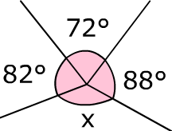 | 118
7 | What is 0.2m in cm? | 20cm
8 | Calculate -3 x -5 | 15
9 | If I buy 3 pens costing £2.75 each, how much change do I get from £10? | £1.75
10 | Expand the following  5(3a + 4) | 15a + 20
11 | Simplify p³ x p⁵ | P⁸
12 | Find the area of the shape below  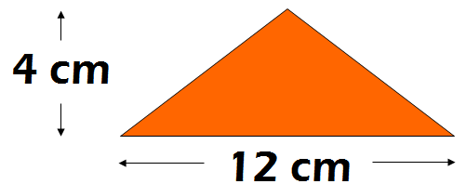 | 24cm²
13 | What is the next 3 numbers in the sequence below?  2, 8, 14, 20… | 26, 32, 38
14 | A bell rings every 8 minutes and another every 10 minutes. They both ring together at midnight. What time will they both ring at the same time again? | 00:40
15 | Write down the name of this 3D shape  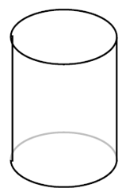 | Cylinder
16 | Simplify  7a + 3b – 5a + 2b | 2a + 5b
17 | Find the median of the following numbers  3 7 2 5 9 11 3 | 5
18 | A bus leaves Hampton at 0853 and arrives at Queensgate at 0911.  How long does the bus take? | 18 minutes
19 | Work out the value of 2³ + 3² | 17
20 | What is the n^{th} term of the following sequence?  6, 10, 14, 18, 22 | 4n + 2
21 | Write down four factors of 18 | 1, 2, 3, 6, 9, 18 (any 4)
22 | Find the mean of the following numbers  9 1 1 6 7 13 2 1 | 5
23 | Divide £35 in the ratio 3:4 | £15, £20
24 | What is the probability of getting a blue on the spinner below?  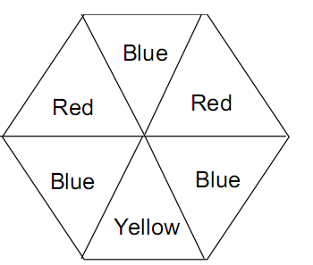 | 0.5
25 | Solve the equation 2g + 5 = 18 | g = 6.5
26 | Find 60 as a product of prime factors | 2² x 3 x 5 = 60
27 | Factorise the following expression  18b + 15 | 3(6b + 5)
28 | Make n the subject of the formula  $$a=\frac{mn}{10}$$ | $$n=\frac{10a}{m}$$
29* | Find the area of the circle  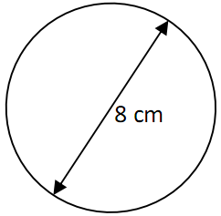 | 50.3cm²
30* | Find the length of the missing side of the triangle  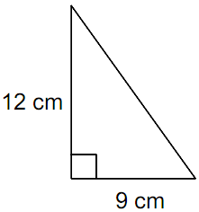 | 15cm

