Foundation GCSE – Essential Skills 1
Mark:
Name:
Underline any words you don’t understand
www.mathedup.co.uk
1 | Find $\frac{2}{5}$ of £25
2 | Calculate 30% of 320kg
3 | Write down the value of $\sqrt{25}$
4 | Simplify  3b x 4c
5 | What is the reciprocal of 3
6 | Work out the angle x  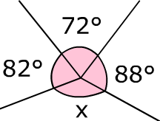
7 | What is 0.2m in cm?
8 | Calculate -3 x -5
9 | If I buy 3 pens costing £2.75 each, how much change do I get from £10?
10 | Expand the following  5(3a + 4)
11 | Simplify p³ x p⁵
12 | Find the area of the shape below  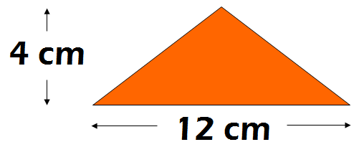
13 | What is the next 3 numbers in the sequence below?  2, 8, 14, 20…
14 | A bell rings every 8 minutes and another every 10 minutes. They both ring together at midnight. What time will they both ring at the same time again?
15 | Write down the name of this 3D shape  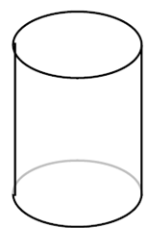
16 | Simplify  7a + 3b – 5a + 2b
17 | Find the median of the following numbers  3 7 2 5 9 11 3
18 | A bus leaves Hampton at 0853 and arrives at Queensgate at 0911.  How long does the bus take?
19 | Work out the value of 2³ + 3²
20 | What is the n^{th} term of the following sequence?  6, 10, 14, 18, 22
21 | Write down four factors of 18
22 | Find the mean of the following numbers  9 1 1 6 7 13 2 1
23 | Divide £35 in the ratio 3:4
24 | What is the probability of getting a blue on the spinner below?  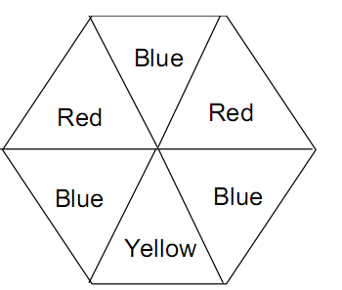
25 | Solve the equation 2g + 5 = 18
26 | Find 60 as a product of prime factors
27 | Factorise the following expression  18b + 15
28 | Make n the subject of the formula  $$a=\frac{mn}{10}$$
29* | Find the area of the circle  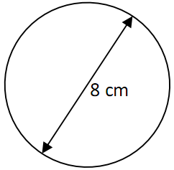
30* | Find the length of the missing side of the triangle  