**C grade Algebra**

* Collecting like terms
* Substitution
* Simple factorisation

[Video](http://www.youtube.com/watch?v=xoRjLmJbcT4)



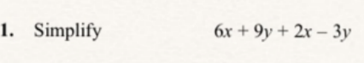

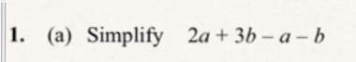

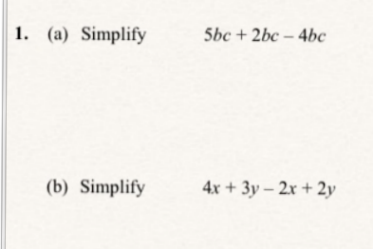

Substitution [video](http://www.youtube.com/watch?v=vvR9WDU-t_s)

Substitute in the number or numbers to get your answer

|  |  |
| --- | --- |
|  |  |

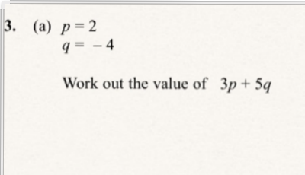

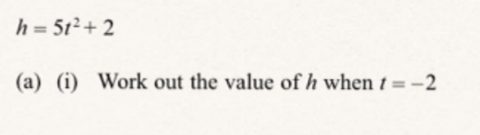

Simple factorising [Video](http://www.youtube.com/watch?v=GVPWF_vkojM)

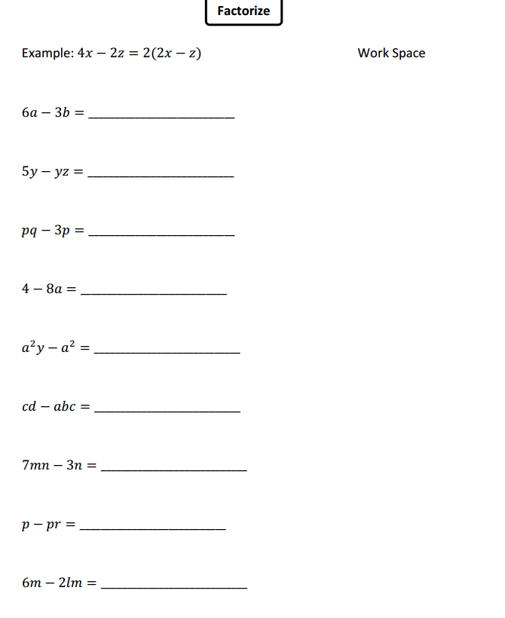

Simple Indices Questions

[Video 1](http://www.youtube.com/watch?v=MqlcVGVZ5_M)

[Video 2](http://www.youtube.com/watch?v=s9KH5Caw6WU)



